Assignment 3 :

- write a SQL query to find Employees who have the biggest salary in their Department
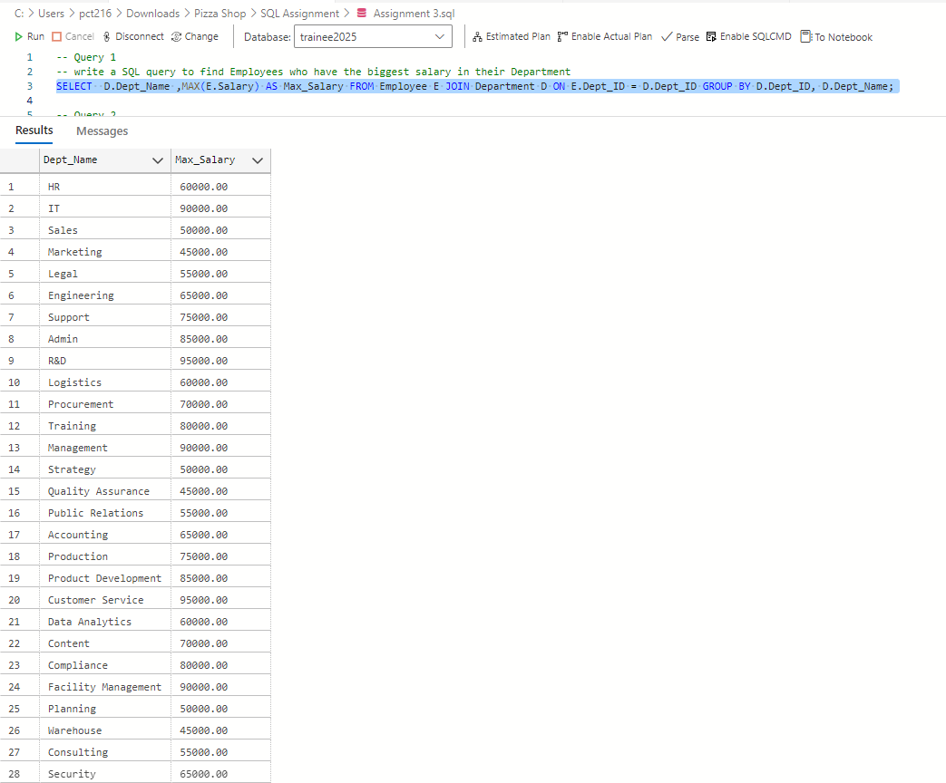

- write a SQL query to find Departments that have less than 3 people in it
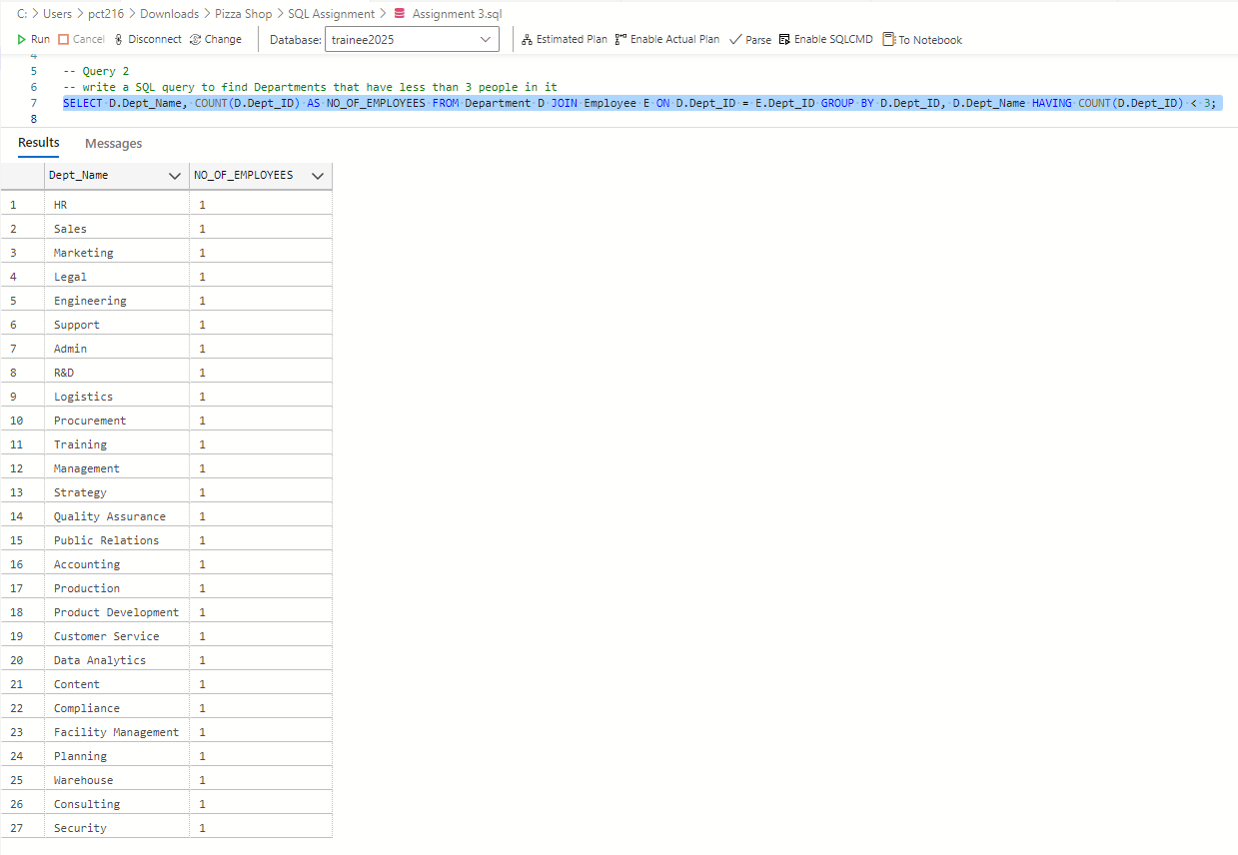

- write a SQL query to find All Department along with the number of people there
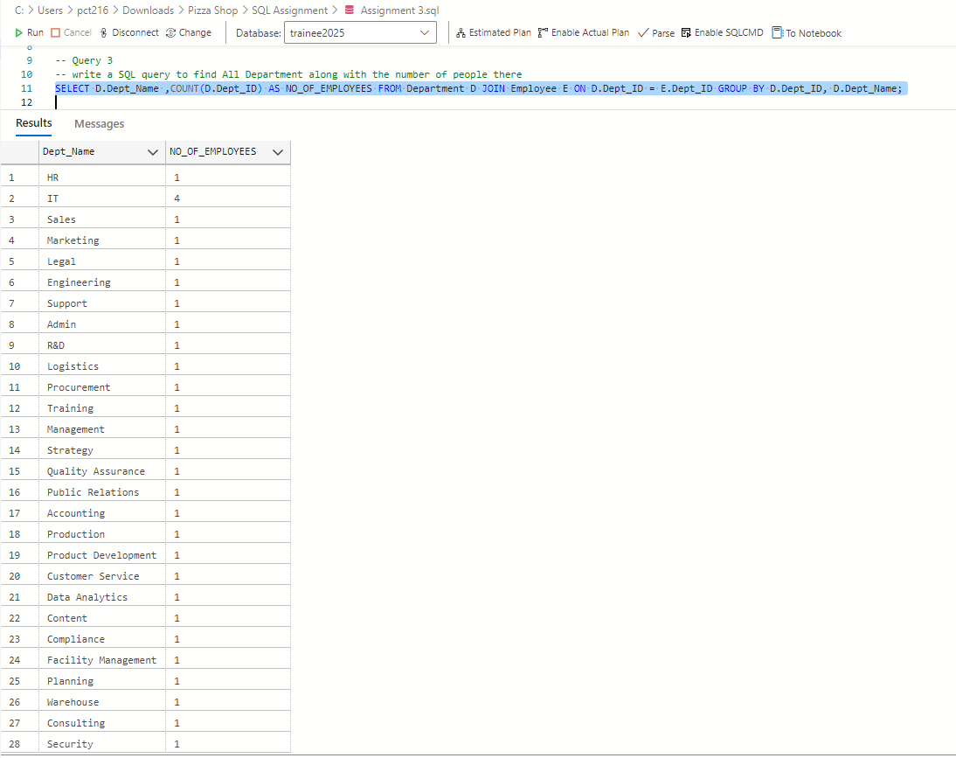

- write a SQL query to find All Department along with the total salary there
